**Getting Around in Bash**

**ubuntu@ip-172-31-7-93:~$ ls –alh**

**(THIS COMMAND WE USE TO CHECK OUR HISTORY)**

**ubuntu@ip-172-31-7-93:~$ ll –h**

**(This command we use to see our Ubuntu directories)**

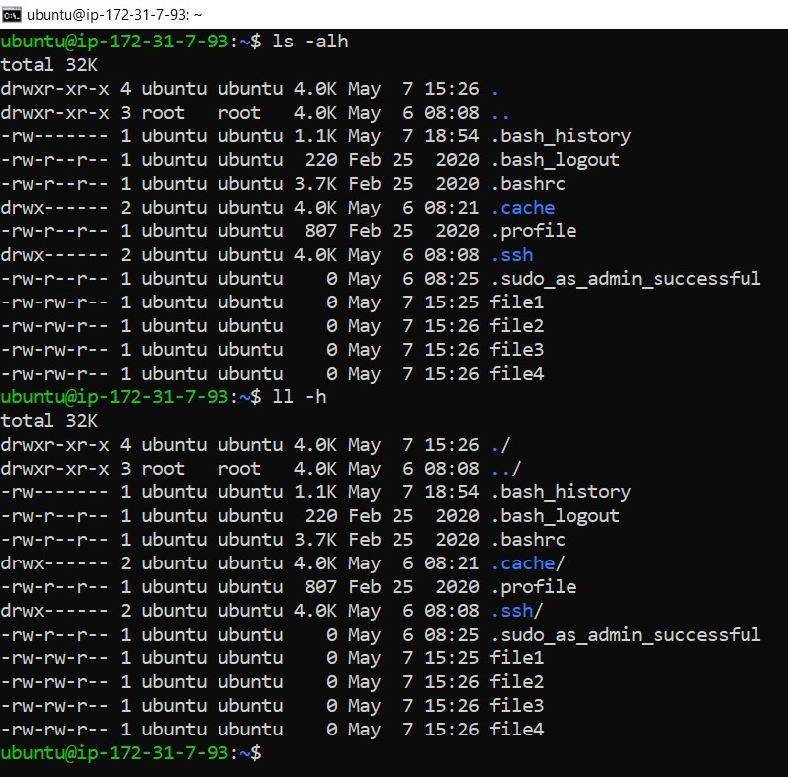

**ubuntu@ip-172-31-7-93:~$ cat /var/log/auth.log**

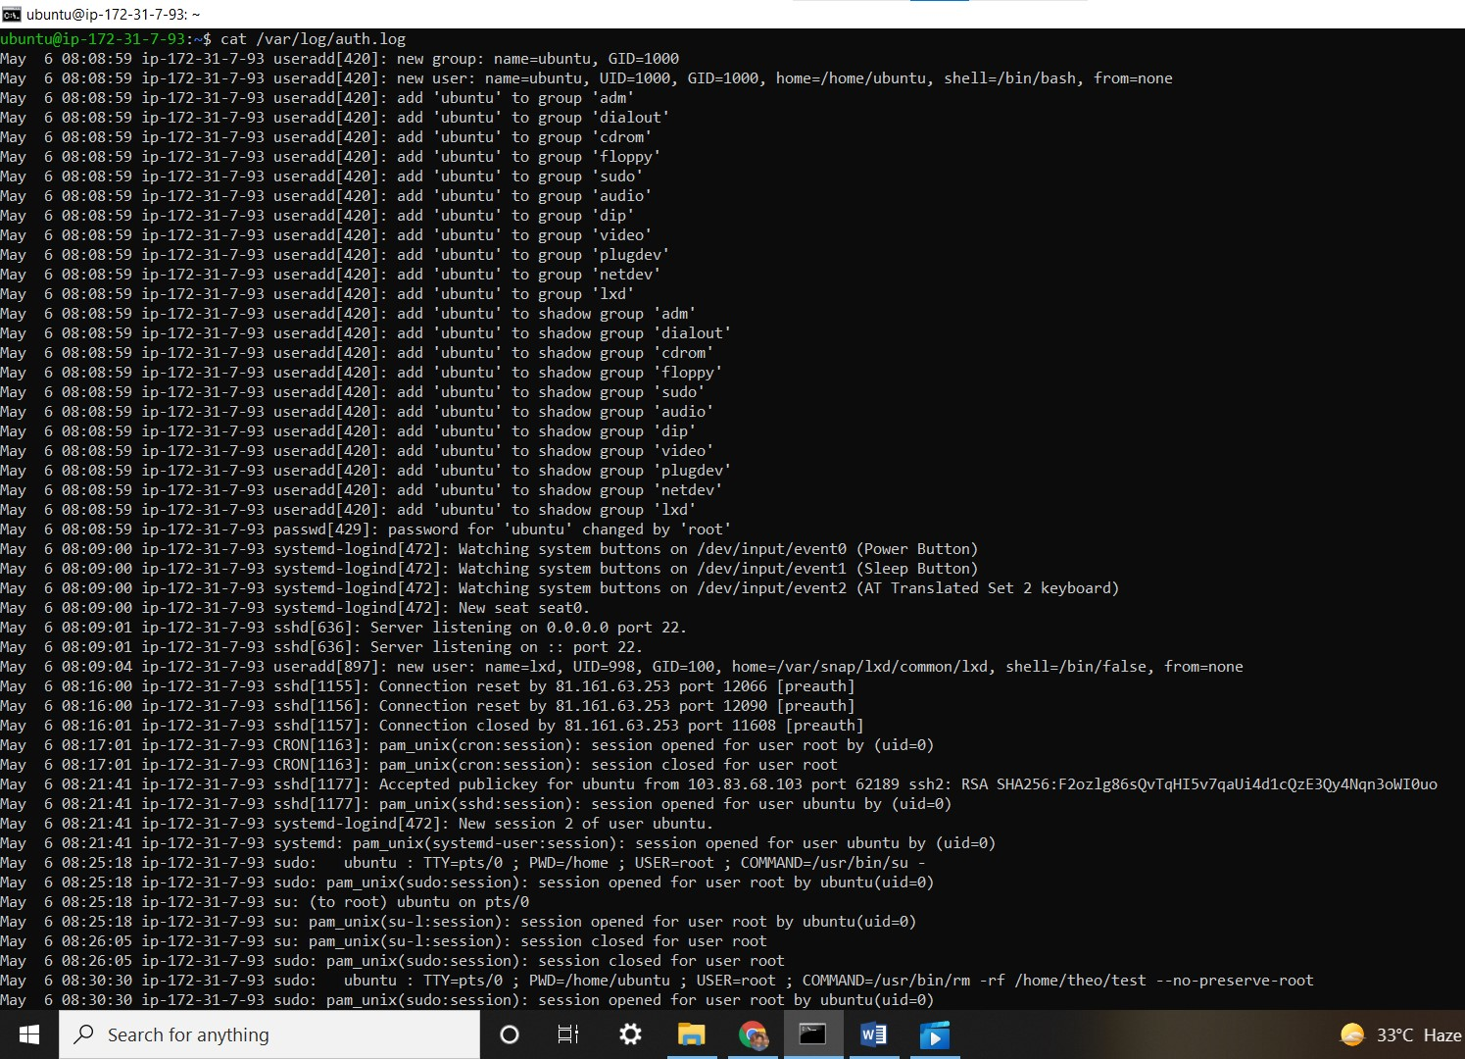

**ubuntu@ip-172-31-7-93:~$ cd /var/**

**ubuntu@ip-172-31-7-93:/var$ cd /var/lo**

*-bash: cd: /var/lo: No such file or directory*

**ubuntu@ip-172-31-7-93:/var$ cd /var/log**

**ubuntu@ip-172-31-7-93:/var/log$ ls**

alternatives.log auth.log cloud-init.log dpkg.log landscape syslog wtmp

amazon btmp dist-upgrade journal lastlog syslog.1

apt cloud-init-output.log dmesg kern.log private unattended-upgrades

**ubuntu@ip-172-31-7-93:/var/log$ cd ..**

**ubuntu@ip-172-31-7-93:/var$ cd log**

**ubuntu@ip-172-31-7-93:/var/log$ cd ../..**

**ubuntu@ip-172-31-7-93:/$ ls –al**

**(it show our directory ,**

**-> . represent our present directory**

**-> .. represent our parent directory**

**-> if we want to go to parent directory put .. )**

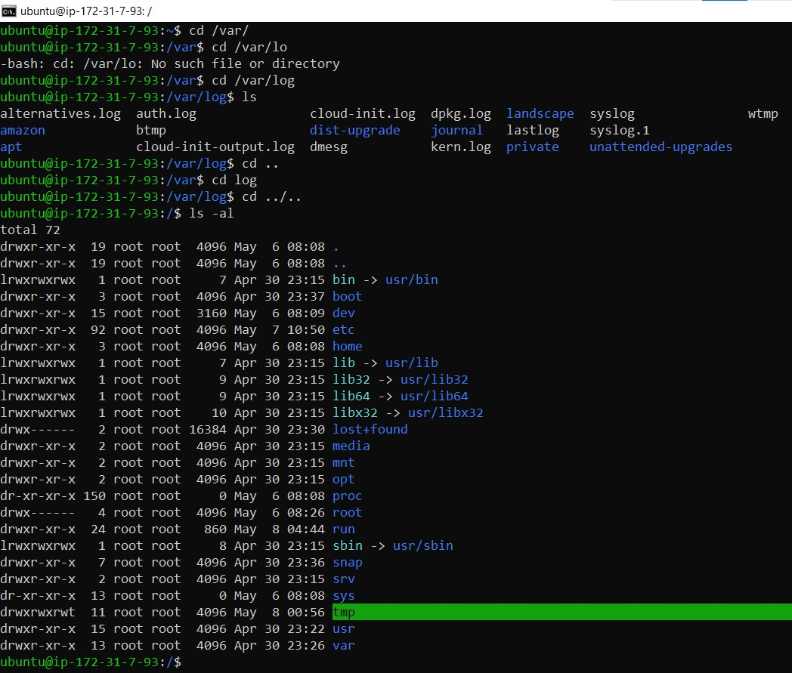

**ubuntu@ip-172-31-7-93:/$ cd /var/log/**

**ubuntu@ip-172-31-7-93:/var/log$ cd ..**

**ubuntu@ip-172-31-7-93:/var$ cd ..**

**ubuntu@ip-172-31-7-93:/$**

